 

**Placement Empowerment Program**

***Cloud Computing and DevOps Centre***

**Write a Python Flask application and deploy it on your cloudVM : Configure the firewall to allow HTTP traffic.**

Name: Kirubalini S I Department: IT



**Introduction**

Developing and deploying web applications is a core aspect of modern software development. Python, with its simplicity and versatility, is a popular choice, and Flask, a lightweight web framework, makes it easy to build web applications quickly. Deploying these applications on a cloud Virtual Machine (VM) provides scalability and accessibility. To ensure that the application is reachable, it's essential to configure the VM's firewall to allow HTTP traffic. This process involves writing the Flask application, setting up the VM, transferring the application, installing dependencies, running the application, and configuring the firewall.

**Objectives**

**Application Deployment:** To successfully deploy a Python Flask web application on a cloud VM.

**Accessibility:** To make the application accessible over the internet by configuring the VM's firewall to allow HTTP traffic.

**Practical Skill Development:** To gain practical experience in deploying web applications on cloud infrastructure.

**Environment Setup:** To establish a functional web application environment on a cloud VM.

**Firewall Configuration:** to allow external traffic to the web application.

**Importance**

**Real-World Application:** Provides a practical understanding of deploying web applications in a production-like environment.

**Scalability and Flexibility:** Cloud VMs offer scalability and flexibility, allowing applications to handle varying traffic loads.

**Accessibility and Availability:** Firewall configuration ensures that the application is accessible to users over the internet.

**Development to Deployment Workflow:** Learning the complete workflow from application development to deployment.

**Cloud Infrastructure Familiarity:** Increases familiarity with cloud infrastructure and its management.

**Testing:** Provides a good test of the code in a live environment.

**Step-by-Step Overview**

Step1:

CREATE AN EC2 INSTANCE

Login into your AWS console and navigate to the EC2 dashboard.

Click on ‘launch instance’ and create your own instance. Ensure your cloud VM is running a Linux distribution (Ubuntu, CentOS, etc.).

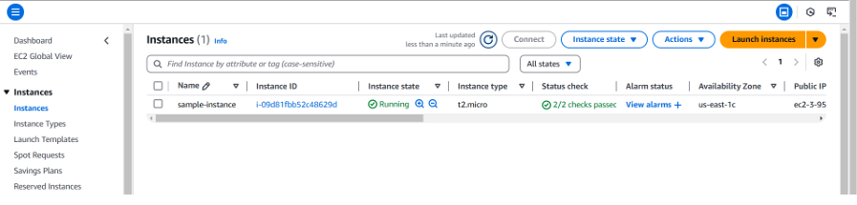

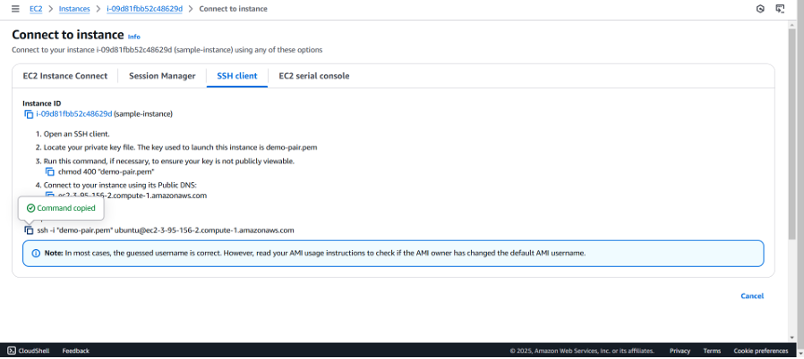

Connect your EC2 instance and copy the ssh command.

Step 2:

INSTALLING AND SET-UP

Open your PowerShell, change the file directory.

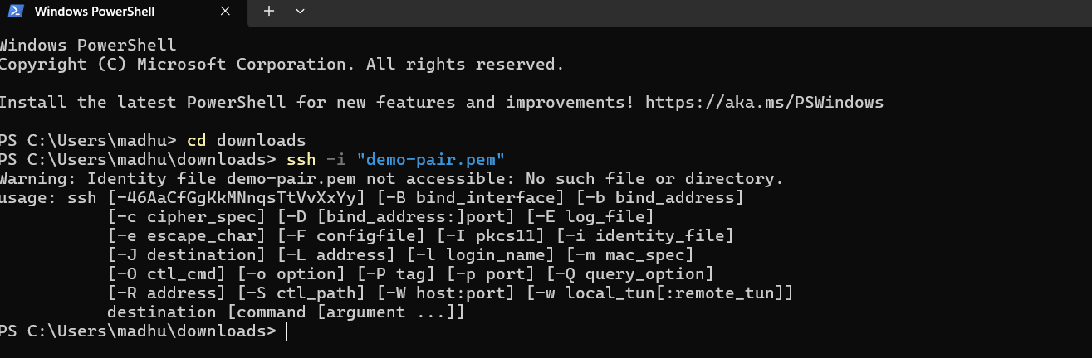

Step 3:

Update & upgrade the package.

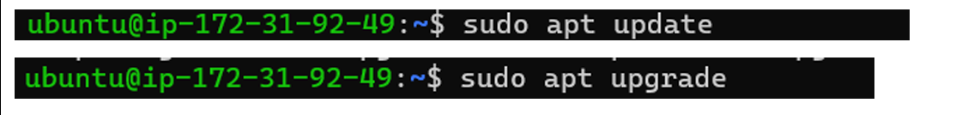

Step 4:

Install python3 and pip.

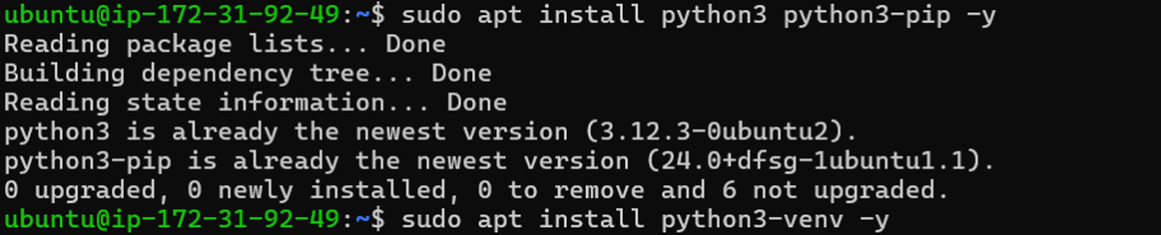

Step 5:

Install Flask.



Step 6:

Create a directory for your app and create a file called ‘app.py’.

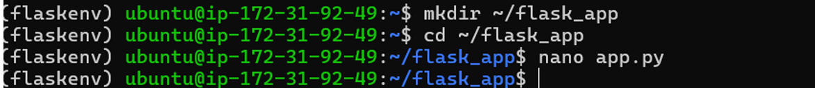

Step 7:

This will open an editor. Write the following code and click enter.

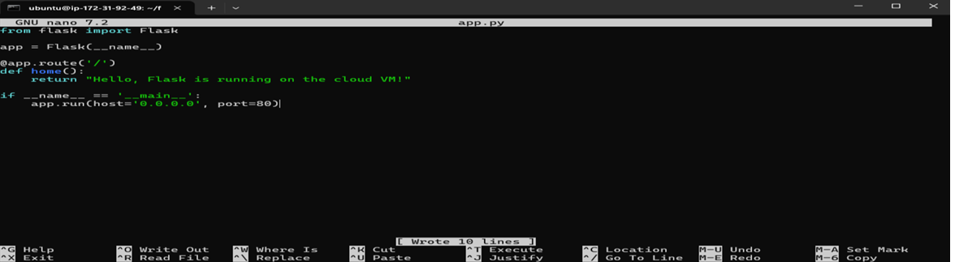

Step 8:

Now, exit the virtual environment. • Then, add your virtual environment’s python path and run the application.

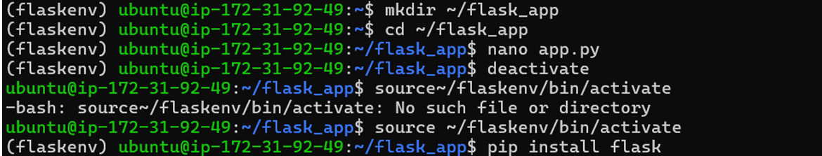

Step 9:

Your Flask is now running!

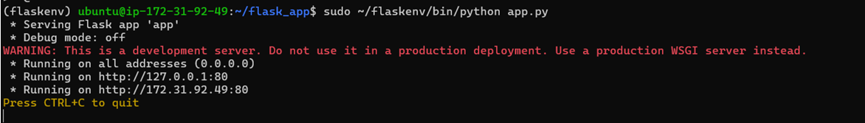

Step 10:

EDIT INBOUND RULES

Go to the EC2 dashboard, > Instances

Find your security group attached to it in ‘network and Security’ section.

Under the inbound rules, ensure that there is a rule for HTTP(port 80)

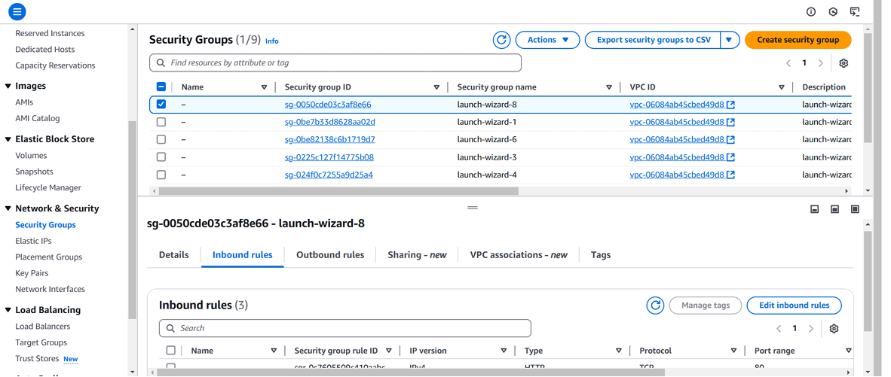

Step 11:

TESTING AND ACCESSING

Open your browser to navigate

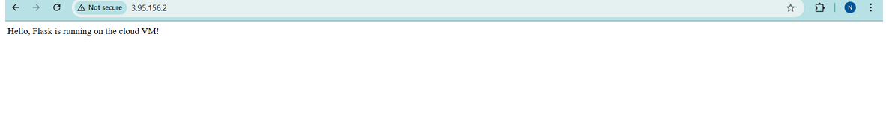

**OUCOMES**

**Functional Web Application:** A working Python Flask web application deployed on a cloud VM.

**Publicly Accessible Application:** The application is accessible over the internet through HTTP.

**Enhanced Development Skills:** Improved skills in web application development and deployment.

**Cloud Infrastructure Proficiency:** Increased proficiency in using cloud VMs and configuring firewalls.

**Practical Experience:** Hands-on experience in deploying and managing web applications in a cloud environment.

**Improved debugging skills:** by working in a live environment, debugging skills are improved.

**Better understanding of network security:** by configuring firewalls, understanding of network security is improved.